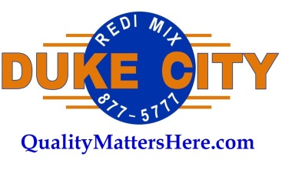

**DCRM is Hiring a Field QC Representative**

Job Brief:

The Field QC Rep is a service and quality focused representative that ensures our customers’ needs are met in the most efficient way, as well as ensuring our product quality is maintained in the field.

Responsibilities:

* Ensure both safety and efficiency by being on site for concrete pours as directed by the Field QC Manager.
* Log all field test results and communicate them to dispatch.
* Work in close communication with dispatch and relay all customer communications.
* Oversee field testing technicians to ensure Duke City quality is protected and well represented.
* Complete raw material testing at the batch plant as needed.

Requirements:

* Must be personable and maintain positive relationships with both internal and external partners including drivers, customers, dispatch, batch employees.
* Should be efficiency focused and able to prioritize the optimal use of time, resources, and effort to achieve the desired outcomes.
* Be proficient with smartphone-based communication.
* A clean driving record is required.
* This position requires a particularly high level of integrity with trustworthiness and honesty being essential qualities for success.
* Should possess strong time management skills.
* Experience in concrete is preferred including an ACI Field Tech Certification.
* This position operates on a six-day-per-week schedule including early mornings and long hours.
* Must have a good grasp on basic math skills.

Reports To: Field QC Manager